d. Git version control

Git is a distributed version control system, meaning that it allows developers to work on their own local copies of a project,

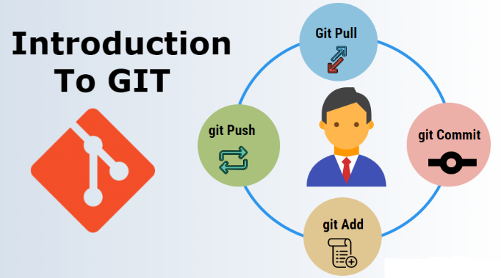Git helps manage and track changes to code, but it does so in a decentralized way

This design makes Git fast, scalable, and highly resilient to issues like server failures

* Why uses Git?

Git becomes a well known tool that developers can use to handle changes to their codes with ease. Given that it is a distributed system, every participant in this project will not only have access to the complete history of all its files but also flexibility is enhanced particularly during offline or remote-related tasks.

* When to use Git?

use Git if we want to collaborate with other developers on a coding project or work on own project.

displays the state of the working directory and the staging area. It lets you see which changes have been staged, which haven't, and which files aren't being tracked by Git. Status output does not show you any information regarding the committed project history.

* Key Features of Git
* Version Tracking: Git follows all adjustments done in one record, letting you revert to old releases without trouble.
* Collaboration: Different programmers can work on a similar task at the same time without clash.
* Branching: You have the option to create distinct branches for new attributes, bug repairs or tests.
* Distributed System: Every programmer has an entire version of the project implying that it is decentralized software.
* Log of Commits: With this feature, Git maintains an account of all commit actions (changes), which makes understanding how a project has evolved over time much easier.